DETECTING THE RISK OF HEART DISEASE WITH FUZZY LOGIC

Sevin Kaşkaya, Damla Mutlu, Ahmet Ozcelik

*Computer Engineering*

*Kocaeli University*

{svd.kaskayaa, damlamutlu123, [ozcelikahmett61}@gmail.com](mailto:ozcelikahmett61%7d@gmail.com)

***Summary*—Today, the number of people with heart disease is increasing day by day. As with any disease, it is very important to diagnose heart diseases early, to determine the risk in advance and** to take the necessary **precautions or to start the appropriate treatment as soon as possible. The continuous development of technology and the use of fuzzy logic systems in the field of health are**  of great importance  **in terms of early diagnosis and correct diagnosis of** **heart** disease**. In this study, a fuzzy system was designed to determine the risk of heart disease. The system consists of 24 rule bases and is in the MISO (Multi Input Single Output) system structure consisting of 6 inputs - single outputs. Input** values **are a person's age, blood pressure, cholesterol, blood sugar, LDL and HDL values. The output value is "risk" It consists of a Mamdani extraction motor and a center of gravity rinser. By applying the necessary procedures to the information received from the user**, the **risk of heart disease of the person is calculated.**

***Keywords – fuzzy logic, fuzzy system, heart disease risk, membership function, rule base, rinse, inference engine***

I.GİRİŞ

Thewhole process of transforming human information and technologies into mathematical modeling with the help of rule bases, fuzzy functions, inference mechanisms, and rinsing operations is called fuzzy logic. With fuzzy systems used in many areas, reliable, fast and precise results can be obtained. In addition to fields such as Engineering and Industry, many studies have been done with fuzzy logic in medicine. One of these studies is disease prediction and diagnosis with fuzzy systems.

Medical diagnosis involves detectingthe disease or disorder in a patient through physical examination, medical tests, or other procedures, while treatment is the treatment of physical, mental, or behavioral problems and is meant to treat or rehabilitate patients. Heart diseasemedications are very important and contain a significant amount of medical records that need to be collected, selectively retrieved, and statistically analyzed. Due to an insufficient number of health care professionals, high cost in terms of funding, unsafe patient medical records, fatigue, emotional conditions and other human factors, these data have not been effectively addressed in the light of traditional methods used in practice among health practitioners in the diagnosis of disease. The limitations of traditional methods for diagnosing diseasesrequire the development of expert systems to help medical practitioners provide effective and efficient medical services to patients at affordable costs, regardless of their geographical location.

Cardiovascular disease is a class of diseases involving the heart or blood vessels (arteries and veins). While it technically refers to any disease that affects the cardiovascular system, it is often used to refer to those related to atherosclerosis (arterial disease). The cardiovascular system, otherwise known as the circulatory system in man, performs the combined function of the heart, blood and blood vessels to transport oxygen and nutrients to organs and tissues in the body and to remove waste products among vital functions. Diseases of the cardiovascular system include those that impair the heart's ability to pump, cause valves to malfunction, or result in narrowing/hardening of the arteries [4].

The heart is themost important part of the human body. The lives of individuals certainly depend on the efficient work of the heart. The normal function of the heart is to pump blood and spread it throughout the body. When the output of the heart is unable to perform normally, a condition known as heart failure occurs, and when the heart is inadequate, other vital organs such as the Kidney, Lungs and Liver are also affected. Heart failure disease and its resulting complications are the main cause of death for both men and women in the most technologically advanced countries of the world. It is also among the top five causes of death in underdeveloped countries.A quarter of all deaths occur in the age group of 25 to 69 years. With the help of normal health parameters such as patients' age, high-density lipid level, low-density lipid level, tot a l cholesterol, k a n pressure, fasting blood glucose level, family history of heart disease, gender, etc. can predict the occurrence of heart disease. Clinical decision support is integrated with the expertsystem used to predict disease and clinical decision support that can reduce medical errors, reduce the variety of undesirable applications, improve patient safety, and improve patient outcomes. Ais [3],[4].

The aim of our project is to help minimize disease-related deaths with early diagnosis and early intervention by finding the risks of heart diseases from people's medical data. Toreduce the mortality rate of cardiovascular disease, like many mortality diseases, the disease must be diagnosed at an early stage. In doing so, we aim to estimate the closest risk using expert opinion and to develop a system that helps cardiologists.

II.LTERATURE STUDY

In the study in Reference 3, a Fuzzy system was designed that predicts Heart disease using personal health data. The authors used blood pressure, total cholesterol, triglycerides, blood glucose, physical activity level, and smokinglevel as input values. For these inputs, fuzzy logic operations were performed over 17 rules. 2 membership functions, 0 and 1, have been defined for disease risk. We examined that 80% of the dataset was used for training and 20% was used for testing.

The authors in Reference 4 similarly designed a system that calculates the risk of heart disease. In this system, we see that a user interface in the form of a web-based user application is preferred. Patient data of a private hospital in Nigeria were used as the dataset. Type of chest pain, blood pressure, cholesterol, resting blood glucose, maximum heart rate, resting electrocardiography (ECG), exercise, old peak (exercise-induced ST depression with rest), thallium screening, gender and age values were preferred as input values. 5 different membership functions are defined as output. These; Healty, Mild, Moderate, Severe, Very Severe.

In addition to the fact that there are around 10 input variables in the sources we examined, 3-4 input values were entered into the fuzzy system. In our project, we realized that a small number of input values could not provide the desired precision in our disease risk calculation and that we had to consider most values for the risk of disease risk of a basic organ such as the heart. By entering all 6 input values into our fuzzy system, we tried to create a precise system with 5 different membership functions.

III.BULANIK MIK.

On the basis of classical logic, 0s and 1sare vâr. Something is "present" or "non-existent", "black" or "white". Fuzzy logic, on the other hand, allows the computer to see "gray" values, unlike classical logic . It is the process of modeling information within various rule bases with the help of blurring and rinsing processes. A fuzzy system; Fuzzy set, linguistic expressions, membership functions, if – then rules, blurring, rinsing, inference

parts and finally the experience and experience of the person. Its inputs and outputs are crisp values.

It is a form of logic put forward in an article published in 1961 by Lutfi Aliasker Zade.

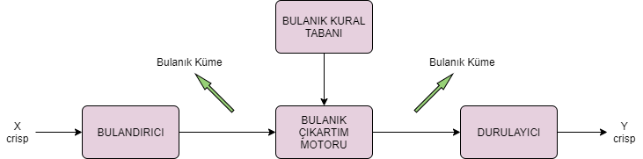

Figure 1. General fuzzy system structure

1. *Membership Fprecepts*

Membership functions are used to mathematically express the relationship of the input values of a fuzzy system to fuzzy sets. The degree of membership indicates how much any input value belongs to a fuzzy set. The membership function is the function that gives the equivalent of the membership degree as a real number.[1] They take values between 0 and 1. Monotonic are increasing and/or monotonic decreasing functions.

In this study, 2 types of membership functions were used. These are the Triangle Membership Function and the Trapezoid Membership Function.

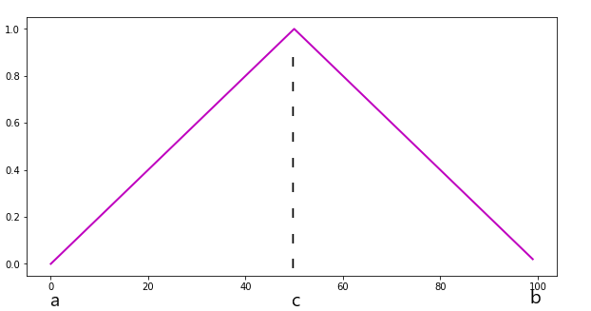

Figure 2. Triangular membership function

The triangular membership function is as shown in figure 2. The mathematical expression of the function is as follows.

$$μ\left(x;a,b,c\right)=\left\{\begin{aligned}\frac{1}{c-a}.\left(x-a\right), a≤x<c \\ \frac{-1}{b-c}.\left(x-b\right), c≤x<b \\ 0, diğer \end{aligned}\right\}$$

The trapezoidal membership function isas shown in Figure 3 and its mathematical expression is given below.

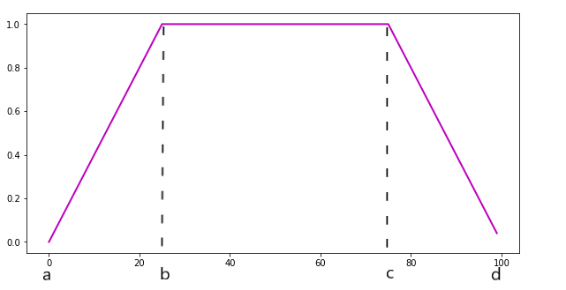

Figure 3.Trapezoidal membership function

$$μ(x;a,b,c,d)\left\{\begin{aligned}\frac{1}{b-a}.\left(x-a\right), a≤x<b \\ 1, b≤x<c \\ \frac{-1}{d-c}.\left(x-d\right), c≤x<d \\ 0, diğer \end{aligned}\right\}$$

1. *Kural Tabansand Çıkartm Mekanizma*

Rule bases are structures in which one or more fuzzy propositions are connected by logical conjunctions to show the relationship between fuzzy sets.

If (if) <fuzzy proposition> then <fuzzy proposition>

* If the vehicle is FAST and the weather is RARAINING, the risk of an accidentis HIGH.

In rule bases, the conjunction "and" symbolizes intersection, and the conjunction "or" symbolizes the union process. In the case of a join operation, the max operator is activated, and in the case of an intersection, the min operator is activated and returns a value.

The inference mechanism, on the other hand, is the part where new information is obtained in the light of old information by using previous information with these rule bases.

The main inference mechanisms used are; Mamdani and Sugeno Inference. [2]

1. *Consolidation and Conversion Operations*

In the blurring process, the crisp values applied to the input are converted to fuzzy values according to the relevant membership function. These values also represent the degree of membership.

At the end of the inference process, we have the fuzzy set. However,since the si stem output is expected to be a crisp, significant value, crisp values are obtained by scaling the fuzzy values according to a certain range in the rinse mechanism.[3]

IV.SİSTEM MİMARİSİ

*I'll write tomorrow*

ETCONUCES

VI.K.

[1] <https://www.muhendisbeyinler.net/bulanik-mantik-nedir/> , [Accessed: 16 December 2019]

[2] <https://medium.com/@ahmetatasoglu98/bulan%C4%B1k-mant%C4%B1k-3-bulan%C4%B1k-kurallar-ve-%C3%A7%C4%B1kar%C4%B1m-8f9d411080c> , [Accessed 16 December 2019]

[3] M. Kowsigan, A. Christy Jebamalar, S. Shobika, R. Roshini, A. Saravanan, “Heart Disease Prediction by Analysing Various Parameters Using Fuzzy Logic”, Pak. J. Biotechnol. Vol. 14, pp. 157- 161, 2017.

[4] O. C. Akinyokun , G. B. Iwasokun, S. A. Arekete, R. W. Samuel, “Fuzzy Logic-Driven Expert System for the Diagnosis of Heart Failure Disease”, Artificial Intelligence Research Vol. 4, No. 1, 2015.